The Enidine Application Worksheet makes Wire Rope Isolator sizing easier and more accurate. Please include as much of the following information as possible and return the Worksheet to the Enidine contact listed. Upon receipt of this worksheet, you will receive a detailed analysis of your application and product recommendations. For custom design projects, an Enidine technical representative will consult with you for specification requirements. Typical report turnaround time is one week.
*If you are unfamiliar with collecting vibration data, please call prior to customer visit and we can help guide you through the process.*

Enidine Contact: | Vincent Cauley | Distributor Name :
Email: | Vincent.Cauley@itt.com | Distributor Contact:
Direct: | (716) 740 - 9210 | Email:
 |  | Direct:

Customer Information:
Contact Name: |  | Company:
Title: |  | Address:
Department: |  | City, State, Zip
Telephone: |  | Email:
Brief description of company’s markets, products and services:

APPLICATION OVERVIEW:
Application sketch, description, background, pictures:

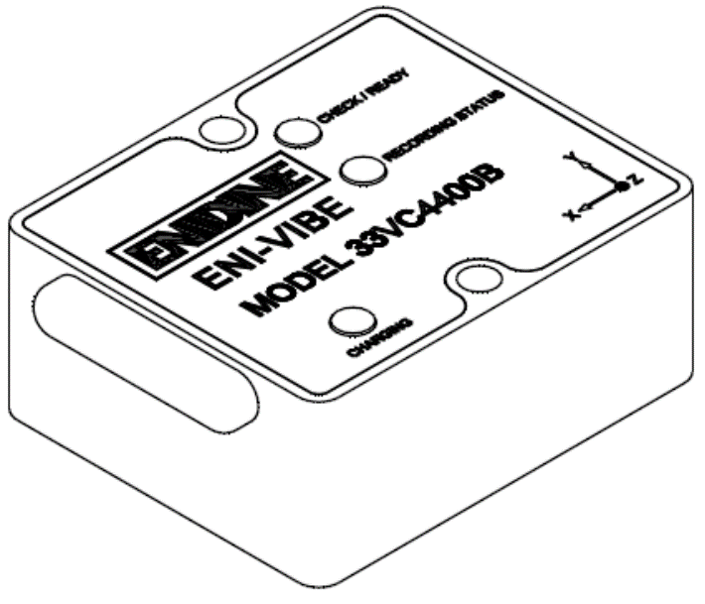
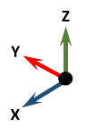
- It is critical to establish X – Y – Z Axes relative to the machinery to be isolated and how each measurement is taken.
- On the top of the Enivibe® unit, the X-Y-Z Axes are noted.
- For each data set recorded, please provide a picture showing the orientation of the Enivibe® as it is attached to the machinery being measured.
- Orientation of isolators, i.e, Compression, Shear/Roll, 45 Deg Comp/Roll
- Anticipated number of isolators

EQUIPMENT TO BE ISOLATED – OEM INFO:
Manufacturer: |  | Weight:
Model: |  | Dimensions:
Fragility: |  | Center of Gravity Location:
PAGE ____ of ____
* Please duplicate this page as required to detail each measurement submitted to Enidine. Please be specific for each data set. Include photos and description..

APPLICATION DATA SET ___ :
DATE OF MEASUREMENT:
Data Filename: |  | Location:
Test Number: |  | Test Conditions:

APPLICATION DATA SET ___ :
DATE OF MEASUREMENT:
Data Filename: |  | Location:
Test Number: |  | Test Conditions:
PAGE ____ of ____

